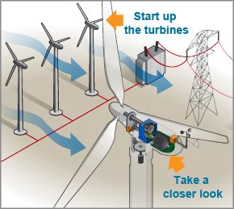

DNA HACKATHON

**Diagnose the Turbine!**

*image source: energy.gov*

SPOC: Harisha, Emp-ID: Harisha.bv, Contact: 9513684878

Context

Wind energy is a clean fuel source unlike power plants. Wind power capacity is increasing on an average around 30% every year. Its sustainable. Wind turbines can be built on existing farms or ranches. But all these advantages come with challenges. In order to further reduce the generation cost, the businesses are coming up with effective control strategies which in turn improvise the performance of wind turbines. Wind operator should know the efficiency of each of the turbines to keep it on or off at appropriate time. Analyzing turbine data is the start point. Along with the prediction of active power, identifying the various factors influencing the potential generation is the important task.

Problem Description

A horizontal axis wind turbine installed in a high wind speed region is to be diagnosed for its performance and operations. The sensors installed at various parts of the whole unit generate all the records for all the relevant features such as power output, wind speed, air density, temperature, blade angles etc. at various time stamp. In order to diagnose this wind turbine, the manufacturer deputes you as an analyst and an engineer for technical advice.

The major tasks of your diagnostics assignment include:

1. Perform exploratory data analysis of all the features (use descriptive statistics and visualization with their interpretations)
2. Impute the missing prices using appropriate reasoning and methods.
3. Filter for removing noise spikes in data
4. Detect anomalies across the features and address the potential causes
5. Prepare descriptive statistics based daily, weekly and monthly rollouts
6. Perform cross sectional analysis of active power and wind speed, wind speed and pitch data, wind speed and temperature data.
7. Explore the major features that contribute to fluctuations in power output and temperatures
8. What are optimal conditions for these features to generate maximum power output from the turbine.
9. Do you notice the turbine to be more productive during any part of the day? (eg: middle of the night/middle of the day etc)
10. Is there any time dependency of turbine performance or any seasonal effect?

Data

The sample indicative data given belongs to the wind turbine which provides one-year intraday data with the time frequency of 10 mins. The data set contains details such as active power, wind speed, pitch, blade data etc., which helps to perform the given task.